** THE RECREATION IT**

Where we Create and Recreate with Creative and Excellent

D block, Aftabnagar Dhaka-1212

Date: June 06, 2022

To,

Rahul Rudra

69,South Nalapara , Sandharghat Road, Chottogram-4100.

Candidate Mobile no: +8801521400202

Candidate Email id: rahulrudra245@gmail.com

**Subject: Appointment Letter as an Internship for the Post of Trainee Developer**

Dear Mr. Rahul Rudra,

This is in reference to your application followed with the rounds of Interview had with us.

We are pleased to appoint you as an Intern to the position of Trainee Developer in our company, with effect from 6th June, 2022 on the following terms and conditions:

* You shall be on Internship as an employment for 3 months from the date of commencement of your service which may be further extended at the discretion of the company. At the end of the Internship period, if your services have been found satisfactory your appointment will be confirmed in writing by the organization.
* Your employment is only for THE RECREATION IT.
* You will be subject to the Company’s rules and regulations for the time being in force and as amended from time to time.
* You have to work 6 hours per day except Sunday.
* During the period of your Internship as an employment, you shall not engage yourself directly or indirectly, with or without remuneration, for any other employment without written permission from the company.
* You shall not disclose any information of the company or any of its customers to anyone which may come to your knowledge.
* After tendering resignation from the company, an employee needs to return all company assets.

I extend a warm welcome to you and wish you all the best for a successful career.

 Best regards,

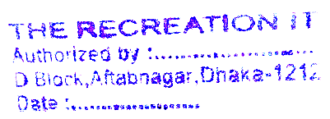

Atm Mushfiq Mahmud

Founder and Managing Director (MD)

The Recreation IT

D block, Aftabnagar Dhaka-1212

Mobile: +8801732368621

Email id: therecreationit@gmail.com